**CS 445 – Week 3 Assignmen**

**Matt Hartigan**

**25-May-2019**

**E5.2a** – Display the SMemberID and SMemberName for all staff members.

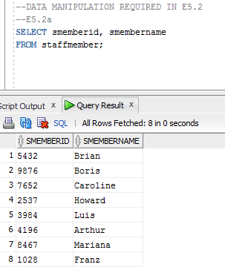

**E5.2b** – Display the CCID, CCName, and CCIndustry for all corporate clients.

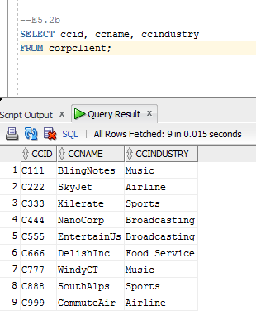

**E5.2c** – Display the BuildingID, BNoOfFloors, and the manager’s MFName and MLName for all buildings.

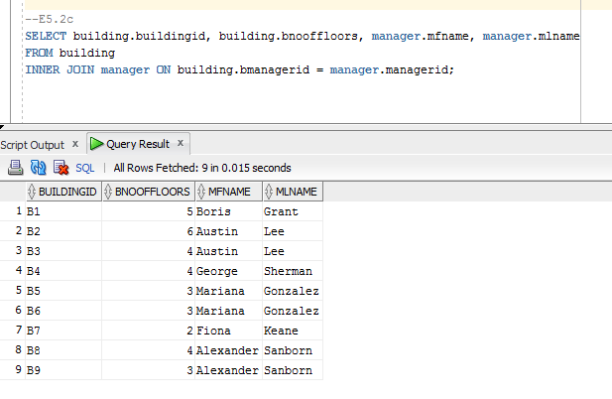

**E5.2d** – Display the MFName, MLName, MSalary, MBdate, and number of buildings that the manager manages for all managers with a salary less than $55,000.

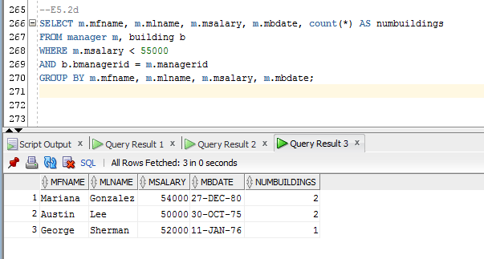

**E5.2e** – Display the BuildingID and AptNo for all apartments leased by the corporate client WindyCT.

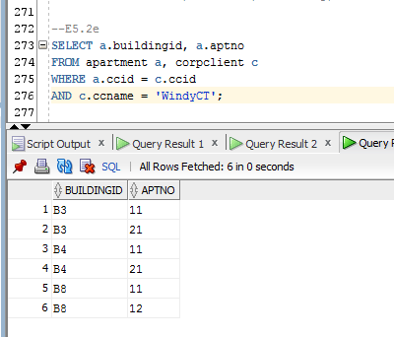

**E5.2f** – Display the InsID and InsName for all inspectors that have any inspections scheduled after 1-JAN-2014. Do not display the same information more than once.

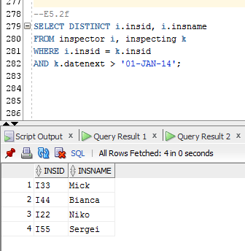

**E5.2g** – Display the SMemberID and SMemberName of staff members cleaning apartments rented by corporate clients whose corporate location is Chicago. Do not display the same information more than once.

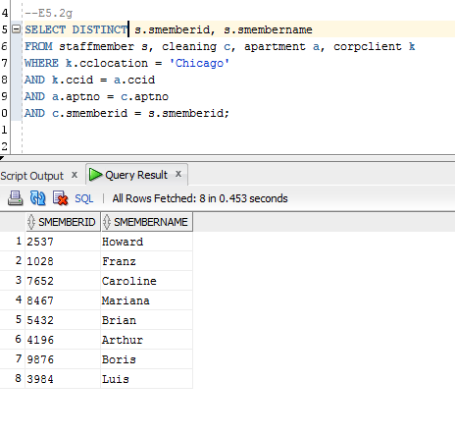

**E5.2h** – Display the CCName of the client and the CCName of the client who referred him or her, for every client referred by a client in the Music industry.

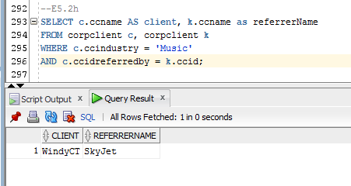

**E5.2i**- Display the BuildingID, AptNo, and ANoOfBedrooms for all apartments that are not leased.

